|  |
| --- |
| MSPM  Sample Alpha Stirling Engine Model |

# Brief Overview of Alpha Stirling Engines

An alpha Stirling engine is a two-piston engine that operates on the Stirling cycle. There is a hot-side piston and a cold-side piston. The working gas can flow from the hot-side piston area, through the hot heat exchanger, through the regenerator, through the cold heat exchanger, to the cold-side piston area. The flow reciprocates through each cycle, and work is extracted from the expansion and contraction of the working gas as it changes temperature.

# Modelling Constraints in MSPM

Models in MSPM must have axial symmetry. Although it is possible to create a more realistic looking model with sections at different angles (for examples having the two pistons rotated 90 degrees from each other) with the use of groups and bridges, for the sake of simplicity, the sample alpha Stirling engine model has been built as a single group with no bridges. This sample engine is not designed to be manufacturable in real life, it is simply designed to showcase MSPMs ability to model and simulate an alpha style Stirling engine.

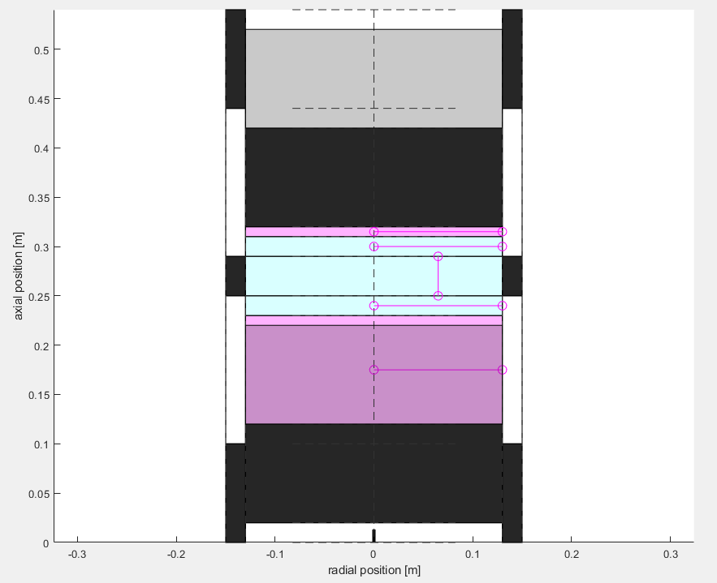

# Bodies

This section explains what each body represents in this model.

MSPM gives perfect insulator bodies a black color, helium gas a pink color, constant temperature heat sources/sinks a white color, and gas bodies with a matrix object a light blue color.

## Outer Walls

The black bodies in the corners represent the walls containing the pistons. They are simply there to seal the working gas inside of the engine, and are perfect insulators to help speed up the simulation with little effect on the results.

## Heat Source/Sink

The white bodies between those black insulator bodies are the constant temperature heat source and heat sink. They represent the area where heat is transferred to the engine in a relatively constant temperature, for example a hot/cold roughly constant temperature fluid flowing through this area. These bodies will transfer heat to/from themselves to surrounding bodies (except perfect insulators), including the working gas through convection across its surface. Since these are directly touching the hot and cold heat exchanger bodies, heat will rapidly transfer to those heat exchangers to keep them close to the source/sink temperatures.

## Pistons

The large black body on the top is the hot side piston, and the large black body on the bottom is the cold side piston. The pistons in this model are made of perfect insulators to speed up simulation time, as using accurate materials will not significantly change working gas temperatures. The actual materials of the pistons have negligible effect on the simulation results in this model, since the material of the pistons does not determine their mass, and the mass of the pistons does not affect the friction they encounter. The strokes of the pistons were chosen to have an approximately ideal compression ratio for the temperature difference between the heat source and sink (450K and 270K respectively). There is a small clearance between the end of the strokes and the heat exchangers, as can be seen in the picture, between the top/hot piston and the hot heat exchanger.

## Working Gas

The pink bodies are the working gas, in this case 99% helium / 1% air. This gas is connected together through the heat exchangers and regenerator, and flows through those areas in a reciprocating manner throughout the cycle.

## Heat Exchangers

The outer light blue bodies are the hot and cold heat exchangers. These are actually 99% helium bodies as well, like the pink bodies, but they have a matrix component to them, hence the light blue shading. These heat exchangers are identical in size and parameters to each other, their only difference is that one is physically connected to the hot source while the other is connected to the cold source. The parameters used for these heat exchangers were simply the default parameters, they may not be physically realistic or ideal, but are good enough for a sample model.

## Regenerator

The inner light blue body in the middle of the model is the regenerator. This is also a 99% helium body with a matrix applied to it. It has 95% porosity with the default wire diameter of 0.1mm. Dimensions of the regenerator and its porosity often have a significant effect on the performance of a Stirling engine, in this case they were somewhat randomly chosen; the engine could be further optimized.

## Other

The black body between the two white constant temperature bodies (source and sink) is a perfect insulator to isolate the source and sink.

# Discretization

Bodies are subdivided/discretized in MSPM to increase the accuracy of simulation and resolution of outputs at the cost of increased simulation time. This MSPM model is very simple and does not have many bodies or require much discretization, so it simulates very quickly. In fact, since perfect insulator bodies have no effect on the temperatures of other bodies, changing the number of nodes in these bodies has no effect on the simulation outputs. Feel free to play around with the amount of discretization subdivisions of different bodies to see how it affects the output PV work and shaft power results. The number of subdivisions has already been tuned for good simulation speed with most of the accuracy of higher subdivision counts. For any model that you will be using a lot, it is usually worth your time to do a few tests to minimize simulation time while maintaining reasonable accuracy, especially for test sets or optimizations where the model will be simulated dozens or even hundreds of times.

# Sensors

The pink lines and circles in the model are line temperature sensors. These will output plots as well as MATLAB data files after each simulation of the model. These plots can be useful in getting a general idea about how well regenerators and heat exchangers are performing.

# Maximum Power

An optimization has been run on this model to find the speed and pressure required for maximum power output. The results were that the maximum power occurs at:

655000 Pa  
36.45 RPM